Feature image: "Discover fine jewelry for less!"

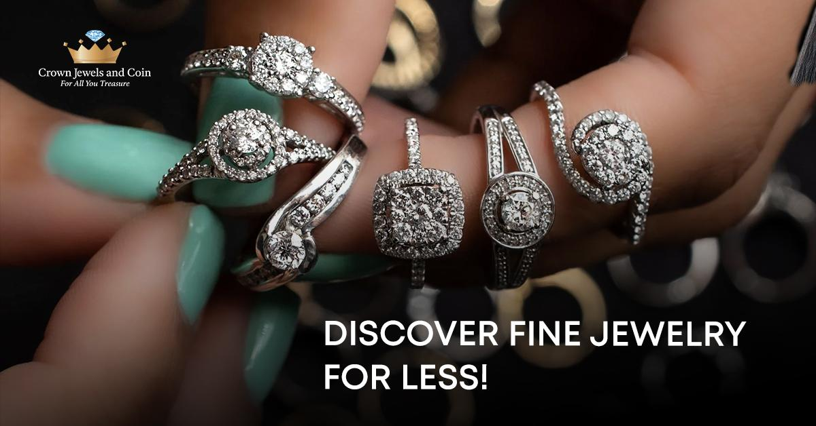 Title: Where to Buy Affordable Fine Jewelry Online
Focus Keyword:
Affordable Fine Jewelry
Secondary keyword
lab grown diamond jewelry
Shop jewelry online with Acima
Acima Leasing for Jewelry

Internal link
best jewelry store in Albuquerque, NM: https://crownjewelsandcoin.com/
Engagement rings for women: https://crownjewelsandcoin.com/collections/engagement-rings
Word count: 1000
Meta Description:
Crown Jewels & Coin offers affordable fine jewelry, lab-grown diamond designs, and Acima Leasing payment plans at your trusted Albuquerque store.

Where to Buy Affordable Fine Jewelry Online h1
Within the price-hiked luxury world, Crown Jewels & Coin creates an accessible space that delivers top-quality and elegant style. As a jewelry store located in Albuquerque, we offer fine jewelry at reasonable prices while delivering upscale quality design. If you are looking for breathtaking, lovely lab-created diamond jewelry, economical at impressions for females, or classic everyday elegance, Crown Jewels & Coin brings exceptional value with no sacrifice. In this post, we will discuss why Crown Jewels & Coin is your go-to place to go for fine jewelry online, how our relationship with Acima Leasing for Jewelry makes luxury more affordable, and what makes us the finest jewelry store in Albuquerque, NM.

Why Choose Crown Jewels & Coin for Affordable Fine Jewelry h2
Crown Jewels & Coin provides exceptional online jewelry shopping by putting customer satisfaction above everything else. Customers choose Crown Jewels & Coin because we offer several unique features.

1. Unbeatable Value Without Compromise h3
From traditional solitaire necklaces to unique lab grown diamond jewelry, Crown Jewels & Coin delivers intricately designed products at prices that count as nothing short of miraculous. Our direct relationships with reliable artisans and fair-minded suppliers keep out the profit margin intermediaries, so what you pay is for craftsmanship, not name. Each item in our collection passed the strict quality control, including the stone clarity, the metal purity, and the structural hardness. For example, our 14K Gold collection is created out of 2.5-micron-thick gold vermeil to promise long-term wear even for daily dressing.

2. Ethical Innovation with Lab-Grown Diamonds h3
For earth-friendly consumers, Crown Jewels & Coin’s lab-created diamond jewelry selection is a new standard. These ones are artificially manufactured in controlled environments and are chemically equivalent to the mined stones. Our brand's cultured diamonds are VS1 clarity and perfectly cut, and are brilliant at a small fraction of the price. Whether you are obsessed with shining princess-cut engagement rings or classic round stud earrings, our unique selection fits classic, modern styles. And also, Crown Jewels & Coin supports eco-friendly techniques through the use of carbon-neutral production methods.

3. Flexible Payment: Online Jewelry Shopping with Acima h3
Luxury can never be overpriced. Crown Jewels & Coin enters into a partnership with Acima Leasing for Jewelry for flexible payment arrangements. The Acima option helps you own luxurious jewelry today by letting you pay over time at no interest for engagement rings and custom pendants alike. You can celebrate your important events without money worries through this buying program, especially for life events. Simply pick Acima during checkout, then select your payment terms to start using your jewelry right away.

4. A Local Legacy with Global Appeal h3
As the top Albuquerque, NM jewelry store, Crown Jewels & Coin provides small-town charm along with a simple online shopping experience. Our local jewelry store gives our customers the opportunity of a personalized consultation, whereas our website provides them with confident browsing, ease of return, and global shipping. Locals sing the praises of our in-house repair services, like ring resizing, engraving & repairs that offer many benefits to our online customers with their stress-free mail-in program.

Crown Jewels & Coins Signature Collections h2

1. Lab-Grown Diamond Jewelry: Shine Consciously h3
Crown Jewels & Coins' lab-grown diamonds are a mark of innovation and ethics. You can explore our curated selection, which includes:

- Women's Engagement Rings: Crown Jewels & Coin offers women engagement rings that combine 14K gold or platinum settings with conflict-free lab-grown diamonds in different vintage and contemporary styles. Customizable choices consist of semi-mixed steel designs and lucky rocks like sapphires or morganite.
- Eternal Bracelets: Tennis bracelets with VS1 clarity lab-grown diamonds, available in white, yellow, or rose gold.
- Everyday Studs: Ideal for giving an outfit a touch of understated sophistication, these studs are available in carat of different weights, with a secure screw-back setting.

2. Affordable Fine Jewelry for Every Occasion h2
Whether you are looking for milestone items or a treat for yourself, Crown Jewels & Coins’ collection has everything for every occasion, uses which include:

- 14K Gold Basics: Simple, yet luxurious chains, hoops, and bangles fit for layering or wearing as her own.
- Birthstone Personalized: Birthstone pendants and birthstone rings, with authentic birthstones, January to December; sapphire, opal, pearl, and more.
- Pearl Classics: Freshwater pearl strands combined with 14K gold details for an elegant look and modern drop earrings.

3. Shop Jewelry Online with Acima: Your Path to Ownership h2
With Acima Leasing for Jewelry, you can have now and pay later. At checkout, simply choose Acima, choose a payment plan, and get your jewelry now. This option is ideal for:
- Engagement rings or any anniversary gift for the option to focus on the quality without the paying tag.
- Creating a considered jewelry wardrobe involving a build-up of pieces over time, piecemeal additions seasonally.
- Spoiling loved ones with heirlooms at budget prices.

What Sets Crown Jewels and Coin Apart? h2

1. Quality Assurance h3
All products go through 100% quality control. Sterling silver rhodium plated to prevent tarnish, gold for enduring wear, and gemstones, all are sourced responsibly. Also, we offer guarantees for clasps, prongs, and mounting for your peace of mind that your jewelry looks as lovely as the day you purchased it.

2. Albuquerque’s Favorite Jewelry Destination h3
The locals know that Crown Jewels & Coin has the best jewelry store in Albuquerque, NM for its:

- Expert Team: With years of industry knowledge, they have expertise in markets to give personalized guidance on stone choice, metal, and style.
- In-House Services: From restoring a ring's fitting feature to replacing a broken pearl necklace string, our craftsmen work through repairs with great care.
- Community Ties: The Crown Jewels & Coin is also involved with local events, from charity auctions to bridal expos, demonstrating our dedication to the city of Albuquerque.

3. Seamless Online Experience h3
The seamless experience our customers enjoy is also one of the reasons that sets us apart. Here are some of the features of our website:

- 360-Degree Product Views: Get up close and personal with intricate features like diamond facets or engraving patterns.
- Virtual Try-On Features: Send in a picture to play with the way rings and necklaces will look on you.
- Live Chat Support: Get real-time help on sizing, materials, or Acima Leasing for a car.

How To Buy Discount Luxury Jewelry Online Safely? h2
Here are some factors you can consider to improve your purchasing experience:
- Set a Budget: Use Crown Jewels & Coins’ price selection to limit options. For instance, sort “Engagement Rings” by price range ( 500–2,000) or metal type.
- Check Product Descriptions: Look at materials, like 14K gold vs. gold plated, and note stone details such as 1/2 ct vs. 1/2 cw.
- Utilize Acima Leasing: Pay high-ticket items like diamond bracelets or wedding bands in affordable installments.
- Explore personalization: Engrave (dates, initials) or resize ring size in checkout for extra personalization.

The Future of Fine Jewelry: Sustainability Meets Affordability h2
Crown Jewels & Coin is on the front lines of the green jewelry movement. With a focus on lab-grown diamonds and recycled metals, we make a far more sustainable choice without sacrificing luxury. Our future collections will see even more cutting-edge materials, such as carbon-free gold and blockchain-confirmed gemstones, totalling complete clarity from mine to market.

Final Thoughts: h3
With regards to budget-friendly fine jewelry, Crown Jewels & Coin is not only a retailer, but an accessible destination for those who appreciate beauty and integrity. With our dedication to ethical business, innovative financing through Acima Leasing for Jewelry, and reputation as Albuquerque's most trusted jeweler, there is no better place to purchase engagement rings for women, lab diamonds, or everyday indulgences.

Head over to CrownJewelsAndCoin.com now and browse our collections to see what jewelry shopping experience you are missing.
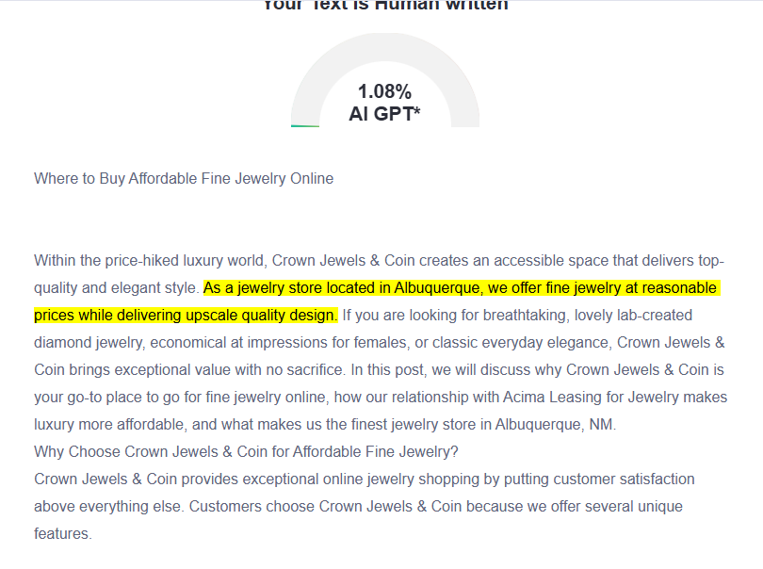
GMB
Crown Jewels & Coin is Albuquerque’s trusted destination for affordable fine jewelry that blends luxury, ethics, and accessibility. As the best jewelry store in Albuquerque, NM, we specialize in stunning lab-grown diamond jewelry, including radiant engagement rings for women, tennis bracelets, and everyday essentials that combine expert craftsmanship with affordable pricing. Our store maintains sustainability practices by using conflict-free lab-grown diamonds together with recycled metals to create eco-friendly, elegant products. Acima Leasing for Jewelry enables our customers to purchase luxury items through interest-free payment plans so they can immediately start using their purchases right away. You can find custom designs and personalized attention through our local stores and our systematic online collection. Our store also provides repairs and custom design services. From timeless pearl strands to modern 14K gold classics, Crown Jewels & Coin delivers heirloom-quality pieces designed to last. Experience seamless shopping with virtual try-on tools, nationwide shipping, and a 30-day return policy. Discover why locals and online shoppers trust us for exceptional craftsmanship, ethical practices, and unbeatable value. Visit us in Albuquerque or explore our catalog at CrownJewelsAndCoin.com today!

